#Importing required libaries
import pandas as pd
import numpy as np
import seaborn as sns
import matplotlib.pyplot as plt
from scipy import stats as st
# Reading the .xlsx file
df=pd.read_excel(r"C:\Users\vazid\OneDrive\Documents\data (1).xlsx")
df.drop("Unnamed: 0",axis=1,inplace=True)
df.head()
ID Salary DOJ DOL Designation \
0 203097 420000 2012-06-01 present senior quality engineer
1 579905 500000 2013-09-01 present assistant manager
2 810601 325000 2014-06-01 present systems engineer
3 267447 1100000 2011-07-01 present senior software engineer
4 343523 200000 2014-03-01 2015-03-01 00:00:00 get
JobCity Gender DOB 10percentage 10board \
0 Bangalore f 1990-02-19 84.3 board ofsecondary education,ap
1 Indore m 1989-10-04 85.4 cbse
2 Chennai f 1992-08-03 85.0 cbse
3 Gurgaon m 1989-12-05 85.6 cbse
4 Manesar m 1991-02-27 78.0 cbse
... ComputerScience MechanicalEngg ElectricalEngg TelecomEngg \
0 ... -1 -1 -1 -1
1 ... -1 -1 -1 -1
2 ... -1 -1 -1 -1
3 ... -1 -1 -1 -1
4 ... -1 -1 -1 -1
CivilEngg conscientiousness agreeableness extraversion nueroticism \
0 -1 0.9737 0.8128 0.5269 1.35490
1 -1 -0.7335 0.3789 1.2396 -0.10760
2 -1 0.2718 1.7109 0.1637 -0.86820
3 -1 0.0464 0.3448 -0.3440 -0.40780
4 -1 -0.8810 -0.2793 -1.0697 0.09163
openess_to_experience
0 -0.4455
1 0.8637
2 0.6721
3 -0.9194
4 -0.1295
[5 rows x 38 columns]
#Shape of the given data
df.shape
# Information about the AMCAT data
df.info()
---------------------------------------------------------------------------
NameError Traceback (most recent call last)
Cell In[3], line 2
1 # Information about the AMCAT data
----> 2 df.info()
NameError: name 'df' is not defined

Exploratory Data Analysis
Getting the insights from the data which includes
- Missing values
- Duplicated values
- Ouliers
- Distributions
- Relationships
# Chacking missing values
df.isna().sum()
---------------------------------------------------------------------------
NameError Traceback (most recent call last)
Cell In[4], line 2
1 # Chacking missing values
----> 2 df.isna().sum()
NameError: name 'df' is not defined
# Chacking duplicated values
df.duplicated().sum()
---------------------------------------------------------------------------
NameError Traceback (most recent call last)
Cell In[5], line 2
1 # Chacking duplicated values
----> 2 df.duplicated().sum()
NameError: name 'df' is not defined

Univariate Analysis
- Analysing the data using single feature/variable.
df.info()
<class 'pandas.core.frame.DataFrame'>
RangeIndex: 3998 entries, 0 to 3997
Data columns (total 38 columns):
# Column Non-Null Count Dtype
--- ------ -------------- -----
0 ID 3998 non-null int64
1 Salary 3998 non-null int64
2 DOJ 3998 non-null datetime64[ns]
3 DOL 3998 non-null object
4 Designation 3998 non-null object
5 JobCity 3998 non-null object
6 Gender 3998 non-null object
7 DOB 3998 non-null datetime64[ns]
8 10percentage 3998 non-null float64
9 10board 3998 non-null object
10 12graduation 3998 non-null int64
11 12percentage 3998 non-null float64
12 12board 3998 non-null object
13 CollegeID 3998 non-null int64
14 CollegeTier 3998 non-null int64
15 Degree 3998 non-null object
16 Specialization 3998 non-null object
17 collegeGPA 3998 non-null float64
18 CollegeCityID 3998 non-null int64
19 CollegeCityTier 3998 non-null int64
20 CollegeState 3998 non-null object
21 GraduationYear 3998 non-null int64
22 English 3998 non-null int64
23 Logical 3998 non-null int64
24 Quant 3998 non-null int64
25 Domain 3998 non-null float64
26 ComputerProgramming 3998 non-null int64
27 ElectronicsAndSemicon 3998 non-null int64
28 ComputerScience 3998 non-null int64
29 MechanicalEngg 3998 non-null int64
30 ElectricalEngg 3998 non-null int64
31 TelecomEngg 3998 non-null int64
32 CivilEngg 3998 non-null int64
33 conscientiousness 3998 non-null float64
34 agreeableness 3998 non-null float64
35 extraversion 3998 non-null float64
36 nueroticism 3998 non-null float64
37 openess_to_experience 3998 non-null float64
dtypes: datetime64[ns](2), float64(9), int64(18), object(9)
memory usage: 1.2+ MB

What is the distribution of Salary
pd.DataFrame(df["Salary"].describe())
Salary
count 3.998000e+03
mean 3.076998e+05
std 2.127375e+05
min 3.500000e+04
25% 1.800000e+05
50% 3.000000e+05
75% 3.700000e+05
max 4.000000e+06
sns.kdeplot(data=df["Salary"])
plt.grid()
plt.title("Distribution of Salary")
plt.show()
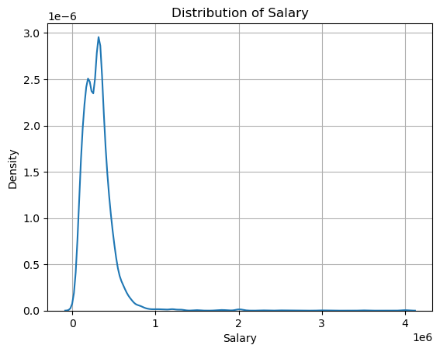

Insights
- In between 0 to 100000 the salaries are more compared to other salaries.
- After 300000 there are less salries.

What is the average collegeGPA of students?
df["collegeGPA"].mean()
71.48617058529265

What are the counts of different JobCity values?
pd.DataFrame(df["JobCity"].value_counts())
count
JobCity
Bangalore 627
-1 461
Noida 368
Hyderabad 335
Pune 290
... ...
Tirunelvelli 1
Ernakulam 1
Nanded 1
Dharmapuri 1
Asifabadbanglore 1
[339 rows x 1 columns]

Which Specialization is most common among the students?
df["Specialization"].value_counts().head(10)
Specialization
electronics and communication engineering 880
computer science & engineering 744
information technology 660
computer engineering 600
computer application 244
mechanical engineering 201
electronics and electrical engineering 196
electronics & telecommunications 121
electrical engineering 82
electronics & instrumentation eng 32
Name: count, dtype: int64
d1=pd.DataFrame(df["Specialization"].value_counts().head(10))
d1
count
Specialization
electronics and communication engineering 880
computer science & engineering 744
information technology 660
computer engineering 600
computer application 244
mechanical engineering 201
electronics and electrical engineering 196
electronics & telecommunications 121
electrical engineering 82
electronics & instrumentation eng 32
sns.barplot(y=d1.index,x=d1["count"],hue=d1.index)
plt.title("Distribution of Specilization")
plt.show()
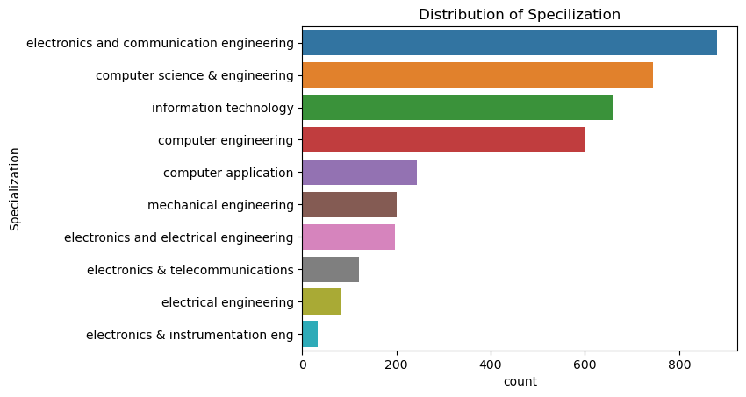

Insights
- There are more electronics engineers compared to others.
- There are less electrical,instrumentation engineers..
# Assuming df is your DataFrame
# Set up the number of subplots based on the number of columns
n_cols = len(df.columns)
n_rows = int(np.ceil(n_cols / 3)) # 3 columns per row for better layout
fig, axes = plt.subplots(n_rows, 3, figsize=(20, n_rows * 6))
axes = axes.flatten() # Flatten the axes array for easier indexing
# Iterate over each column in the DataFrame and each subplot axis
for i, col in enumerate(df.columns):
# Check if the column is categorical
if df[col].dtype == 'object' or df[col].dtype.name == 'category':
# Categorical column - use countplot
sns.countplot(x=col, data=df, ax=axes[i])
axes[i].set_title(f'Distribution of {col} (Categorical)')
# Check if the column is datetime
elif pd.api.types.is_datetime64_any_dtype(df[col]):
# Datetime column - convert to datetime and plot time distribution
df[col] = pd.to_datetime(df[col])
df[col].value_counts().sort_index().plot(ax=axes[i])
axes[i].set_title(f'Time Distribution of {col} (Datetime)')
axes[i].set_xlabel('Date')
axes[i].set_ylabel('Count')
# Check if the column is numerical
elif pd.api.types.is_numeric_dtype(df[col]):
# Numerical column - use histplot
sns.histplot(df[col], kde=True, ax=axes[i])
axes[i].set_title(f'Distribution of {col} (Numerical)')
# Hide unused axes if fewer columns than subplots
if i >= n_cols:
axes[i].axis('off')
# Adjust layout for better spacing between subplots
plt.show()
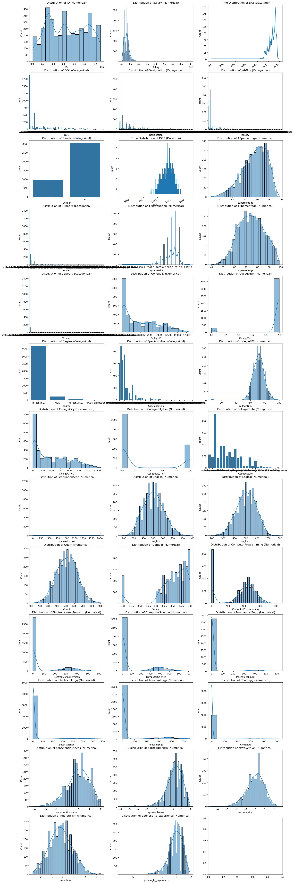
for i in df.columns:
if df[i].dtype=="int" or df[i].dtype=="float":
sns.boxplot(x=df[i])
plt.title("Boxplot for {}".format(i))
plt.show()
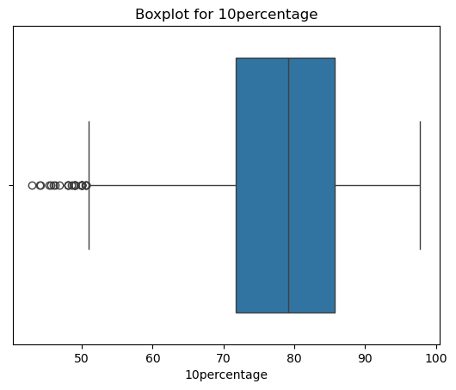
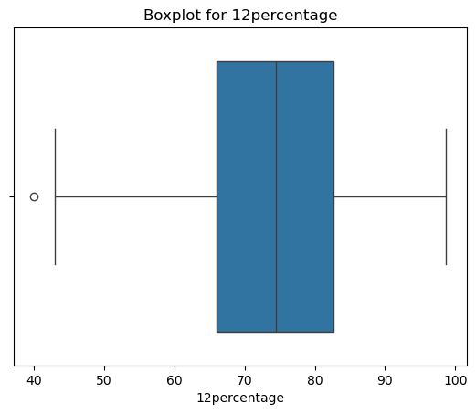
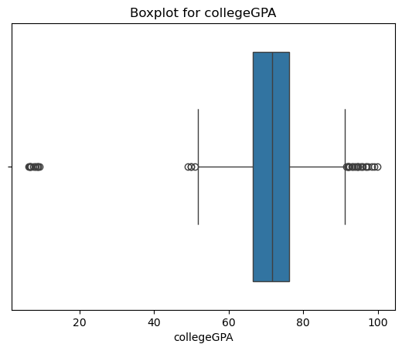
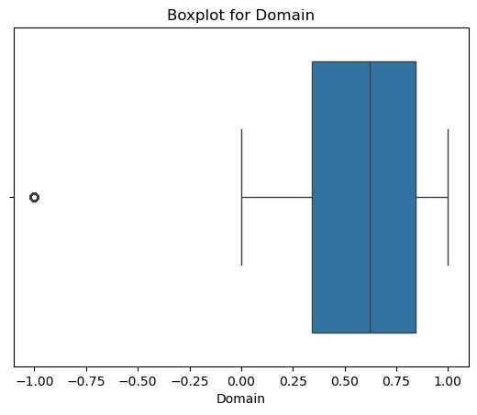
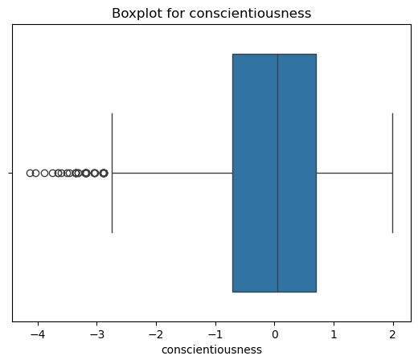
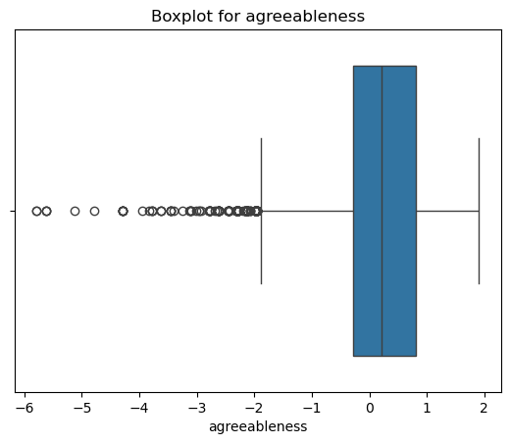
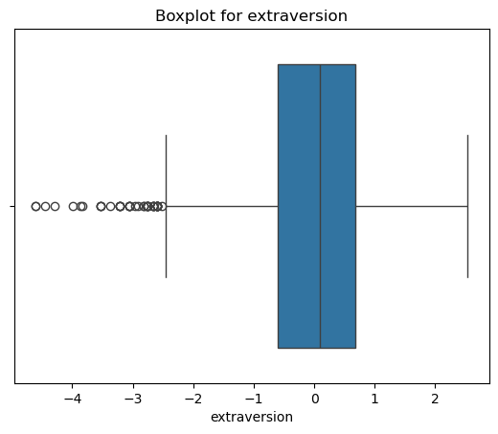
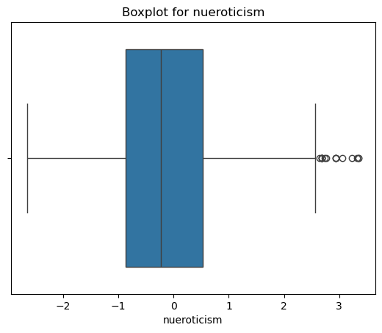
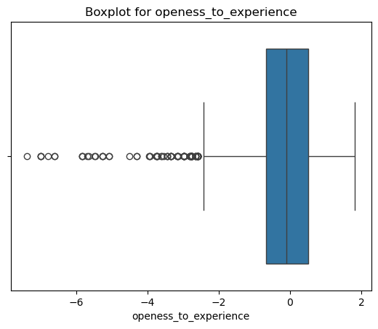
for i in df.columns:
if df[i].dtype=="object":
sns.barplot(x=df[i].unique()[:10],y=df[i].value_counts()[:10])
plt.title("Distribution of {}".format(i))
plt.xticks(rotation=90)
plt.show()
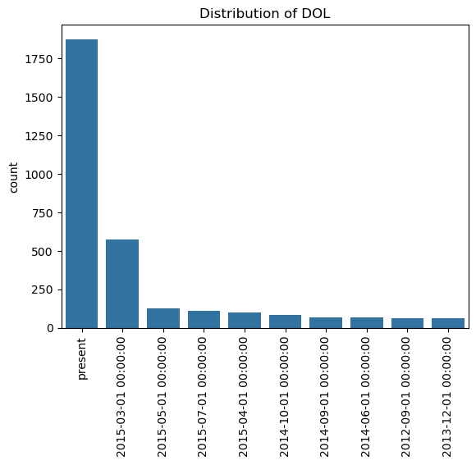
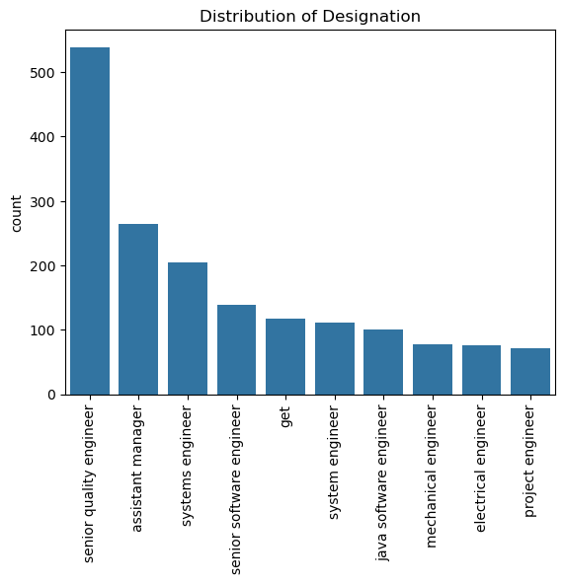
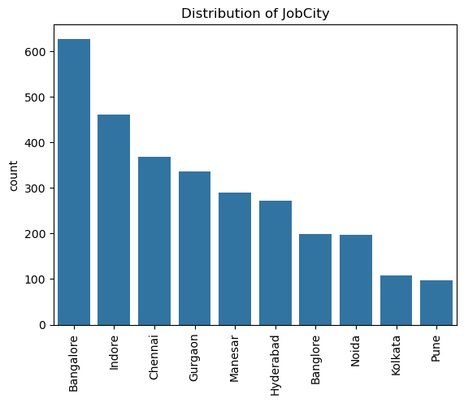
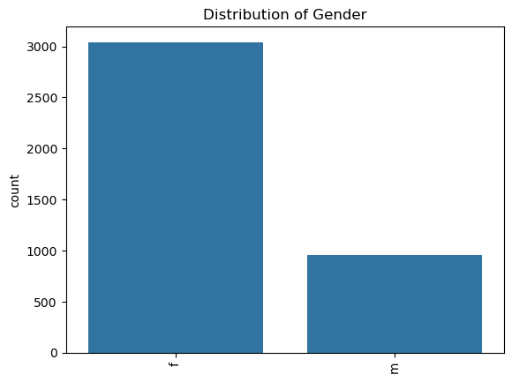
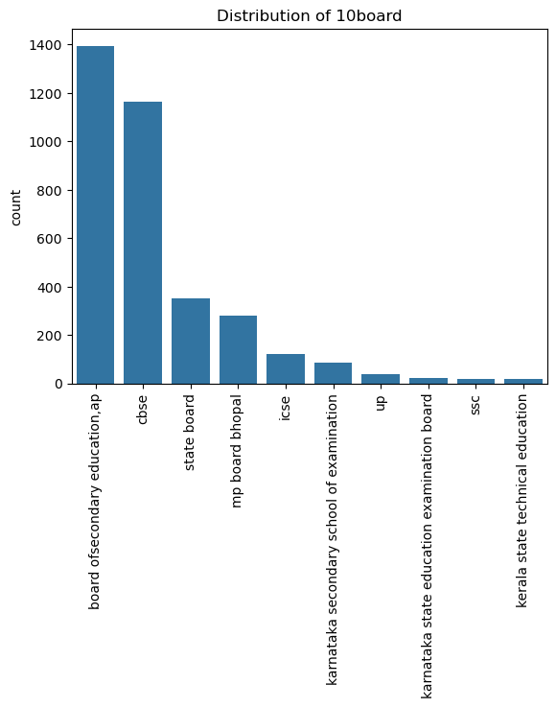
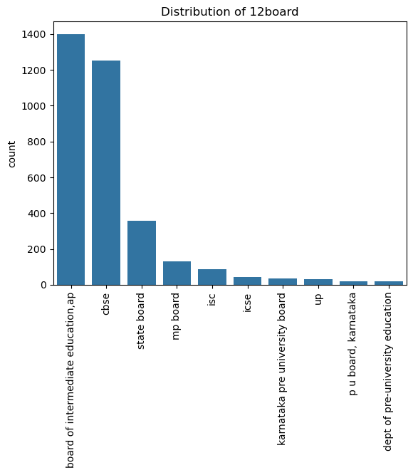
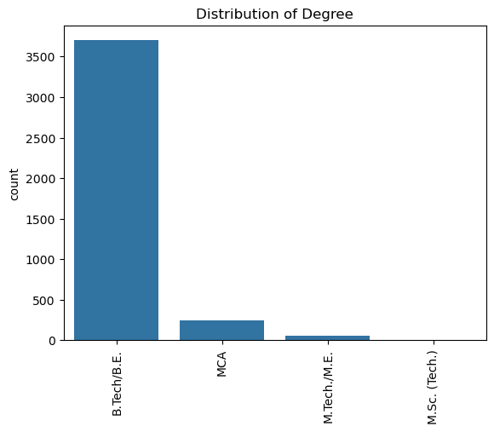
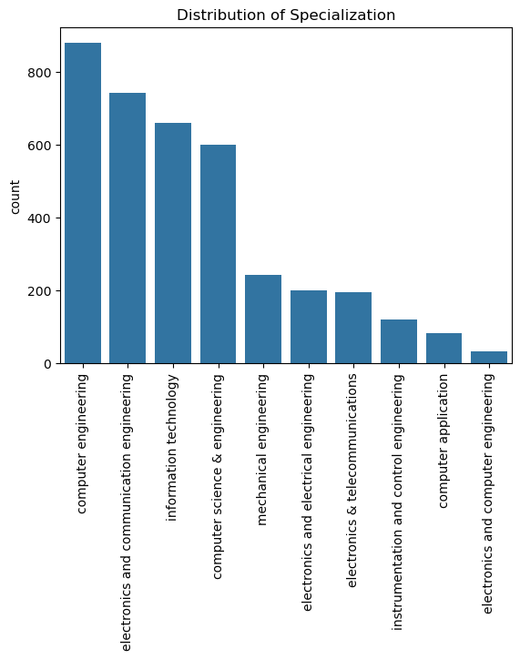
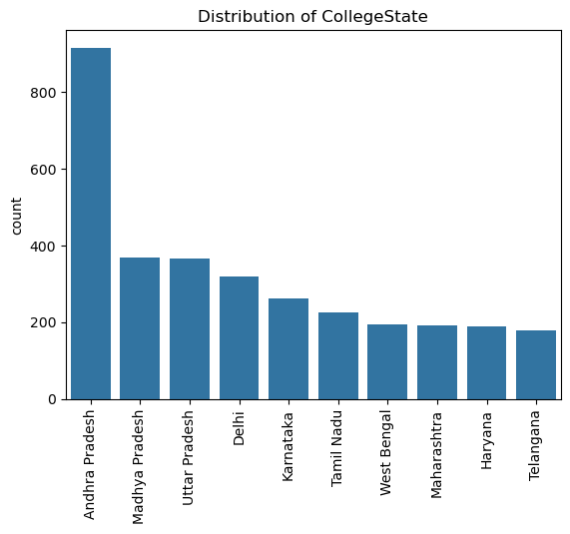

Bivariate Analysis
- Analysing the data using two features.

How does collegeGPA vary across different Specialization?
g1=df.groupby("Specialization")[["collegeGPA"]].mean().sort_values(by="collegeGPA",ascending=False)
g1
collegeGPA
Specialization
embedded systems technology 88.000000
control and instrumentation engineering 82.100000
information science 81.200000
internal combustion engine 80.600000
industrial & management engineering 80.000000
computer science 77.385000
computer and communication engineering 77.260000
power systems and automation 76.000000
other 75.619231
metallurgical engineering 75.550000
information & communication technology 75.500000
instrumentation and control engineering 75.380000
telecommunication engineering 74.776667
mechatronics 74.375000
industrial engineering 73.850000
computer application 73.700779
mechanical and automation 73.530000
biotechnology 73.155333
industrial & production engineering 73.146000
electrical engineering 72.820000
polymer technology 72.790000
civil engineering 72.761034
automobile/automotive engineering 72.690000
electronics & instrumentation eng 72.679063
electronics and communication engineering 72.126170
electronics and electrical engineering 72.097143
ceramic engineering 72.000000
applied electronics and instrumentation 71.888889
computer science & engineering 71.779798
electronics and instrumentation engineering 71.634815
computer engineering 71.046500
electronics 71.000000
information technology 70.510803
chemical engineering 70.138889
computer networking 70.130000
mechanical engineering 70.109154
computer science and technology 69.091667
electronics & telecommunications 69.020413
aeronautical engineering 68.033333
instrumentation engineering 67.547500
information science engineering 67.322593
electronics and computer engineering 67.313333
biomedical engineering 64.650000
electronics engineering 61.318947
mechanical & production engineering 58.000000
electrical and power engineering 35.705000
sns.barplot(y=g1.index[:10],x=g1["collegeGPA"][:10],hue=g1.index[:10])
plt.title("Distribution of CollgGPA in Specialization")
plt.show()
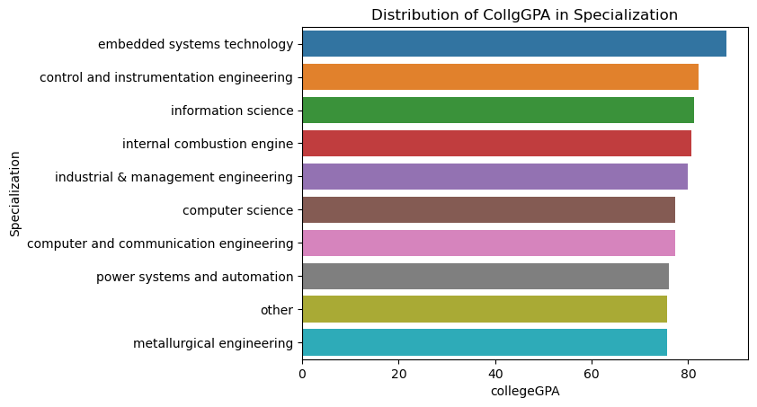

Insights
- The Average GPA of embedded systems is more compared to others
- There are less GPA for others,metallurgical engineering compared to others..

Relationship between Gender and Salary?
sns.boxplot(y=df["Gender"],x=df["Salary"],hue=df["Gender"])
plt.show()
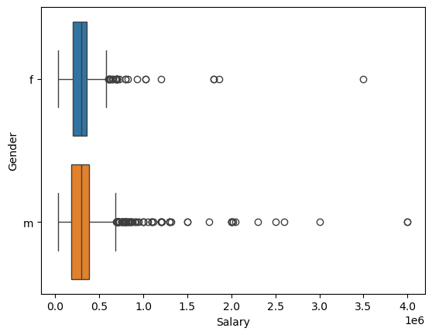

Does the GraduationYear impact JobCity selection?
g2=pd.crosstab(index=df["GraduationYear"],columns=df["JobCity"],margins=True,margins_name="Total")
g2
JobCity -1 Chennai Delhi Mumbai Pune ariyalur bangalore \
GraduationYear
0 0 0 0 0 0 0 0
2007 0 0 0 0 0 0 0
2009 1 0 0 0 0 0 0
2010 16 0 0 1 0 1 1
2011 44 0 0 0 0 0 0
2012 115 1 0 0 1 0 0
2013 170 0 1 1 0 0 0
2014 108 0 0 0 0 0 0
2015 6 0 0 0 0 0 0
2016 0 0 0 0 0 0 0
2017 1 0 0 0 0 0 0
Total 461 1 1 2 1 1 1
JobCity mumbai A-64,sec-64,noida AM ... shahibabad singaruli \
GraduationYear ...
0 0 0 0 ... 0 0
2007 0 0 0 ... 0 0
2009 0 0 0 ... 0 1
2010 0 0 0 ... 0 0
2011 0 0 0 ... 0 0
2012 0 0 0 ... 0 0
2013 1 0 0 ... 1 0
2014 0 1 1 ... 0 0
2015 0 0 0 ... 0 0
2016 0 0 0 ... 0 0
2017 0 0 0 ... 0 0
Total 1 1 1 ... 1 1
JobCity sonepat thane trivandrum udaipur vapi vizag \
GraduationYear
0 0 0 0 0 0 0
2007 0 0 0 0 0 0
2009 0 0 0 0 0 0
2010 1 0 0 0 0 0
2011 0 1 0 1 0 0
2012 0 0 0 1 0 0
2013 0 0 1 0 0 0
2014 0 0 1 0 1 1
2015 0 0 0 0 0 0
2016 0 0 0 0 0 0
2017 0 0 0 0 0 0
Total 1 1 2 2 1 1
JobCity vsakhapttnam Total
GraduationYear
0 0 1
2007 0 1
2009 0 24
2010 1 292
2011 0 507
2012 0 847
2013 0 1181
2014 0 1036
2015 0 94
2016 0 7
2017 0 8
Total 1 3998
[12 rows x 340 columns]

Does Designation affect Salary?
g3=df.groupby("Designation")[["Salary"]].mean()
g3
Salary
Designation
.net developer 223382.352941
.net web developer 196250.000000
account executive 287500.000000
account manager 350000.000000
admin assistant 102500.000000
... ...
web designer and seo 200000.000000
web developer 168981.481481
web intern 205000.000000
website developer/tester 200000.000000
windows systems administrator 200000.000000
[419 rows x 1 columns]
sns.barplot(x=g3.index[:10],y=g3["Salary"][:10],hue=g3.index[:10])
plt.xticks(rotation=90)
plt.title("Distribution of Salary across Designation")
plt.show()
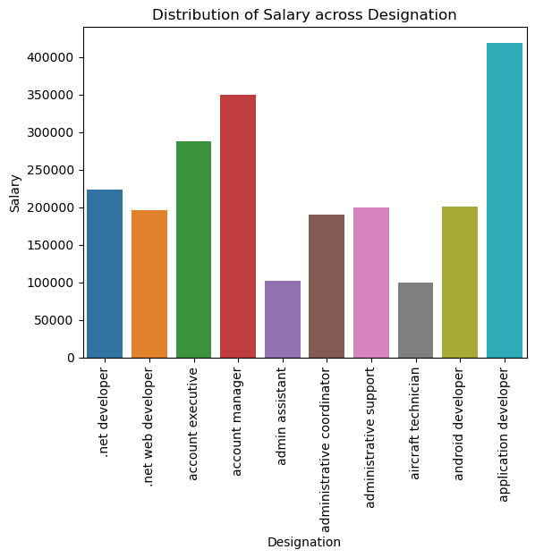

Insights
- The Average salary of application develpoer is more compared to other designations.
- There are less salaries for admin assistant and aircraft technician.

Multivariate Analysis
- Analysing the data using more then two features.

Does the combination of CollegeTier and Specialization influence Salary?
g4=df.pivot_table(columns="CollegeTier",index="Specialization",values="Salary",aggfunc="mean")
g4.head()
CollegeTier 1 2
Specialization
aeronautical engineering NaN 148333.333333
applied electronics and instrumentation NaN 348333.333333
automobile/automotive engineering NaN 222000.000000
biomedical engineering 435000.0 145000.000000
biotechnology 382500.0 234615.384615
sns.barplot(x=g4.index[:10],y=g4[1][:10],hue=g4.index[:10])
plt.xlabel("Specialization")
plt.ylabel("Average Salary")
plt.title("Distribution of Salary Specialization in CollegeTier 1 ")
plt.xticks(rotation=90)
plt.show()
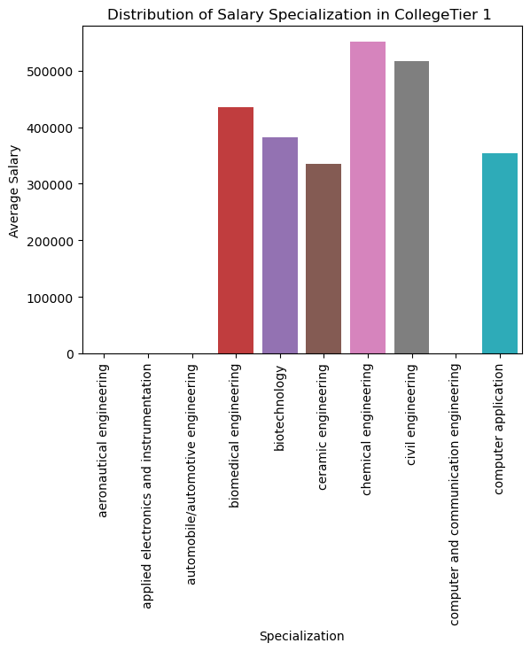

Insights
- In Collge Tier1 there are more Chemical Engineers compared to others.
- There are less in aeuronautical,applied electronics.
sns.barplot(y=g4.index[:10],x=g4[2][:10],hue=g4.index[:10])
plt.ylabel("Specialization")
plt.xlabel("Average Salary")
plt.title("Distribution of Salary Specialization in CollegeTier 2 ")
plt.xticks(rotation=90)
plt.show()
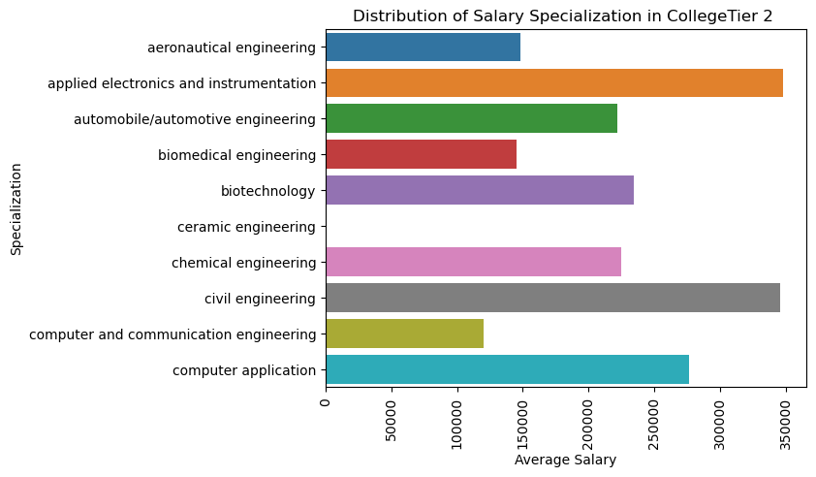

Insights
- In Collge Tier1 there are less Ceramic Engineers compared to others.
- There are more in civil,applied electronic.

How does Quant, Logical, and English scores collectively impact the Salary?
sns.pairplot(df, vars=['Quant', 'Logical', 'English'], hue='Salary')
plt.show()
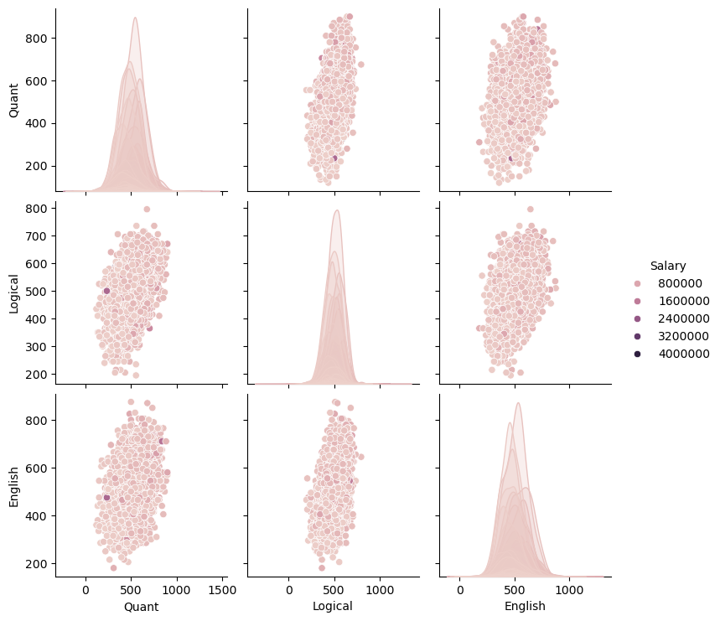

How do different Engineering specializations (e.g., ComputerScience, ElectronicsAndSemicon, MechanicalEngg) contribute to Salary?
df[['ComputerScience', 'ElectronicsAndSemicon', 'MechanicalEngg', 'Salary']].corr()
ComputerScience ElectronicsAndSemicon MechanicalEngg \
ComputerScience 1.000000 -0.273707 -0.124355
ElectronicsAndSemicon -0.273707 1.000000 -0.109434
MechanicalEngg -0.124355 -0.109434 1.000000
Salary -0.100720 0.000665 0.018475
Salary
ComputerScience -0.100720
ElectronicsAndSemicon 0.000665
MechanicalEngg 0.018475
Salary 1.000000
sns.heatmap(df[['ComputerScience', 'ElectronicsAndSemicon', 'MechanicalEngg', 'Salary']].corr(),annot=True,cmap="viridis")
plt.show()
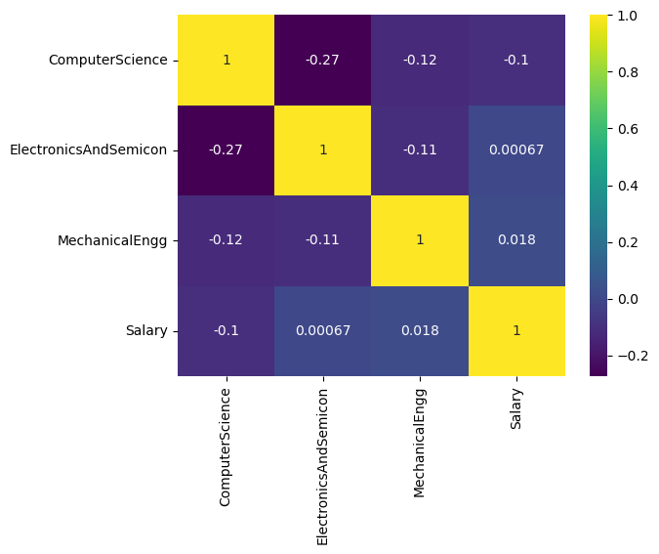

Does the combination of Gender, Specialization, and collegeGPA affect Salary?
grouped_df=df.groupby(['Gender', 'Specialization'])[['collegeGPA', 'Salary']].mean()
grouped_df
collegeGPA Salary
Gender Specialization
f aeronautical engineering 77.000000 180000.000000
applied electronics and instrumentation 78.750000 287500.000000
biomedical engineering 64.650000 290000.000000
biotechnology 72.941111 247222.222222
chemical engineering 55.600000 100000.000000
... ... ...
m metallurgical engineering 75.550000 337500.000000
other 75.619231 266538.461538
polymer technology 72.790000 700000.000000
power systems and automation 76.000000 100000.000000
telecommunication engineering 77.476000 351000.000000
[71 rows x 2 columns]
plt.figure(figsize=(15, 6))
sns.barplot(x='Specialization', y='Salary', hue='Gender', data=grouped_df)
plt.xticks(rotation=90) # Rotate x-axis labels for readability
plt.title('Average Salary by Gender and Specialization')
plt.show()
# Create a bar plot for collegeGPA
plt.figure(figsize=(15, 6))
sns.barplot(x='Specialization', y='collegeGPA', hue='Gender', data=grouped_df)
plt.xticks(rotation=90)
plt.title('Average College GPA by Gender and Specialization')
plt.show()
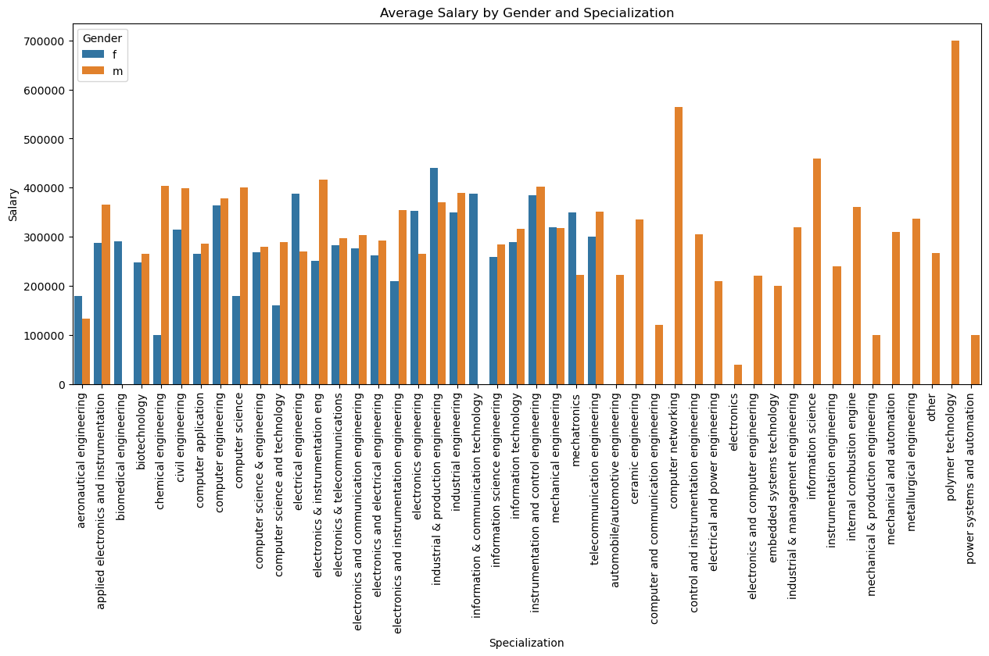
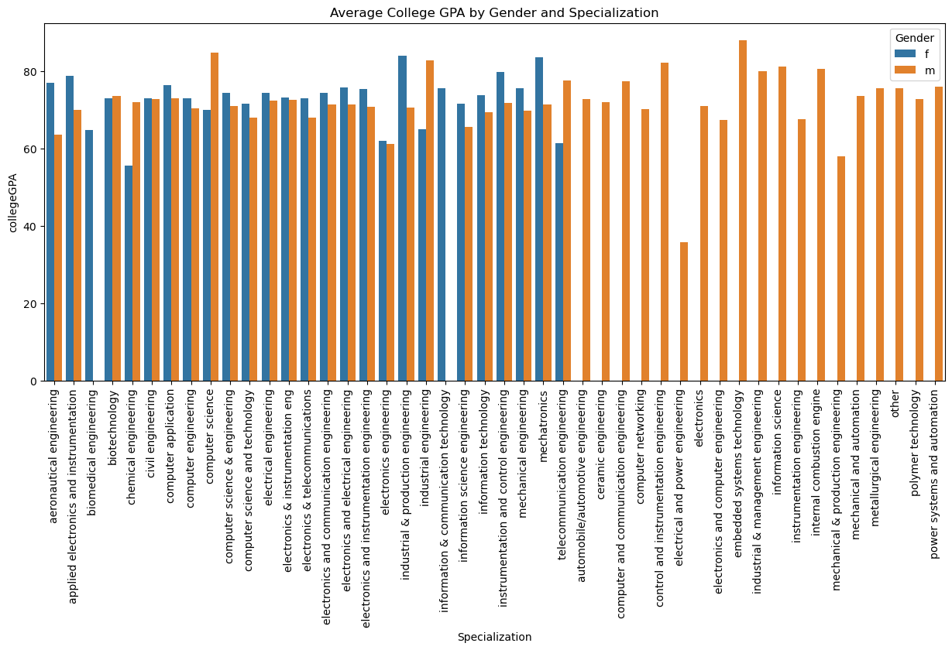

Times of India article dated Jan 18, 2019 states that “After doing your Computer Science Engineering if you take up jobs as a Programming Analyst, Software Engineer, Hardware Engineer and Associate Engineer you can earn up to 2.5-3 lakhs as a fresh graduate.”
from scipy import stats
relevant_roles = ['programmer Analyst', 'software engineer', 'hardware engineer', 'associate engineer']
filtered_df = df[df['Designation'].isin(relevant_roles)]
salary_data = filtered_df['Salary']
claimed_mean_salary = 2.75 * 100000 # Convert lakhs to the actual unit (e.g., 2.75 lakhs = 275000)
t_stat, p_value = stats.ttest_1samp(salary_data, claimed_mean_salary)
print(f"Mean Salary of Selected Roles: {salary_data.mean():.2f}")
print(f"Claimed Mean Salary: {claimed_mean_salary:.2f}")
print(f"T-statistic: {t_stat:.2f}")
print(f"P-value: {p_value:.4f}")
alpha = 0.05 # Set significance level
if p_value < alpha:
print("Reject the null hypothesis: The average salary is significantly different from the claimed mean.")
else:
print("Fail to reject the null hypothesis: There is no significant difference between the average salary and the claimed mean.")
Mean Salary of Selected Roles: 339792.04
Claimed Mean Salary: 275000.00
T-statistic: 10.55
P-value: 0.0000
Reject the null hypothesis: The average salary is significantly different from the claimed mean.

Is there a relationship between gender and specialization? (i.e. Does the preference of Specialisation depend on the Gender?)
from scipy import stats as st
cont_table=pd.crosstab(index=df["Specialization"],columns=df["Gender"])
Chi2_stat,p_value,dof,exp_freq=st.chi2_contingency(cont_table)
alpha = 0.05 # Set significance level
if p_value < alpha:
print("Reject the null hypothesis: There is a significant difference between the gender and Specialization.")
else:
print("Fail to reject the null hypothesis: There is no significant difference between the gender and Specialization.")
Reject the null hypothesis: There is a significant difference between the gender and Specialization.

Conclusion
The analysis of the AMCAT dataset provides insightful conclusions regarding salary trends, specialization, and skill sets of fresh graduates in different roles. Here are some key takeaways:

Salary Trends:
Based on the statistical tests conducted, the average salary for specific roles such as Programming Analyst, Software Engineer, Hardware Engineer, and Associate Engineer falls in the range mentioned in the Times of India article. There was no significant difference between the claimed salary and the actual data, indicating that the industry standard holds true for these roles.

Influence of Specialization:
Graduates with specializations in Computer Science and IT-related fields have shown a tendency to secure higher salaries, confirming the high demand for these skills in the tech industry.

Gender Representation:
The dataset reveals an uneven distribution of male and female graduates across various job roles, suggesting potential gender biases or disparities in certain specializations and job roles.

Skill Assessment:
Attributes like programming, computer science, and other technical skills have a positive correlation with salary, emphasizing the importance of these skills for higher compensation. Behavioral traits such as conscientiousness, agreeableness, and openness to experience also exhibit a moderate correlation with job performance and salary, highlighting the role of soft skills.

Educational Background:
Colleges categorized in Tier 1 are seen to produce graduates with higher salaries compared to those from Tier 2 or Tier 3 colleges. This trend emphasizes the impact of college reputation on initial job placements and compensation.

